Noora Saeed Alhajeri
User Manual



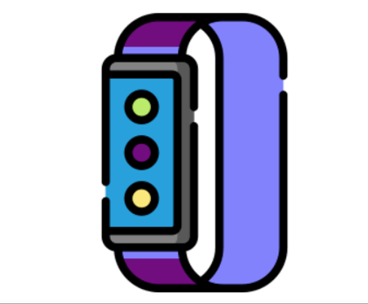

Wearable IoT Based Device for Critical Care Alzheimer's Patients

Please read the instruction manual before use.
All rights reserved.
Specifications are subject to change without notice.

CE/ ISO13485


zhilife.ae.ac.com
www.zhilife.ae.ac.com
0509626466
UAE, AbuDhabi,ZhiLife

Table of Contents

- Introduction…………………………….4
  - Intended Use……………………4
  - Guide to Symbols………………5
  - Unpacking……………………...6

- Using the Device……………………....6
  - Open the Web-sit……………....7
  - Typical steps………………..….7
  - Start monitoring……………......8
  - Stop monitoring & sync data…..8
  - Real-time Dashboard…………..8
  - View Results and Report………8
- Maintenance……………………………8
  - Cleaning……………………......8
  - Battery………………………….9
- Troubleshooting……………………......9
- Technical Specifications………………10
- Electromagnetic Compatibility………..11
LIMITED WARRANTY AND LIMITATION OF LIABILITY

Customers enjoy a one-year warranty from the date of purchase.
This warranty does not cover disposable batteries, damages from misuse accident, neglect, alteration, contamination, or abnormal conditions of operation or handling, including failure caused by use outside of the product’s specifications, or normal wear and tear of mechanical components.

- Consult your doctor immediately if you experience symptoms that could indicate acute disease.
- Do not self-diagnose or self-medicate on the basis of this device without consulting your doctor. In particular, do not start taking any new medication or change the type and/or dosage of any existing medication without prior approval.
- Functional tester cannot be used to assess the accuracy of a measurement sensor or a device.

1.2Guide to Symbols
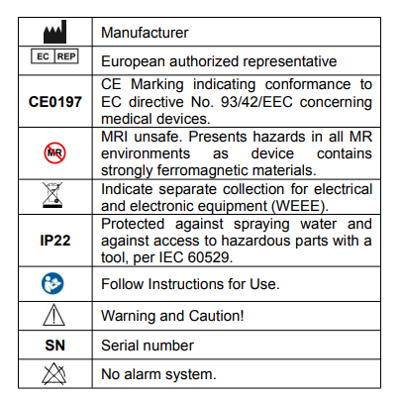

1.Introduction

1.1Intended Use

This product is intended to be used for Alzheimer’s patients, and it is measuring, displays, and storying pulse rate, temperature, and fall detection with a GPS module in a home or healthcare facility’s environment. The website can show real-time data; get the record, and display results and reports.

Note:
The data and results provided by this device are for pre-check screening purposes only and cannot be directly used for diagnosis or treatment.

The data provided by the website is optional) is not intended for diagnosis or treatment purposes, always consult your doctor for any health condition.

- Warnings and Cautionary Advice
- DO NOT squeeze the sensor or apply excessive force on the sensor.
- Do not use this device during MRI examination.
- Never submerge the device in water or other liquids.
- Do not place this device in pressure vessels or gas sterilization device.

2.2Typical Steps

START: Connect the battery. Wear the device with the cover.
STOP: Take off the hand band, the recording will be over after the countdown.
DATA SYNC: Run the Website to sync data.

2.3Start monitoring
1) Connect the battery to the device.
2) Wear the device on the hand as a hand-band.
3)After a few seconds, the device will begin to monitor. (If the working time is less than 1minute, the data will not be saved)

NOTE:
- The device can also work as a fall detection with display Google Map on the website.
- Please avoid any strong ambient light conditions.

2.4Stop monitoring & sync data
- Take off the device, the countdown will begin. During the countdown, if you wear the device again, the record will be resumed.

1.3Unpacking

Main Unit (Hand-band device) x1
Hand-band Cover x1
Lithium-ion battery x1
User Manual x1
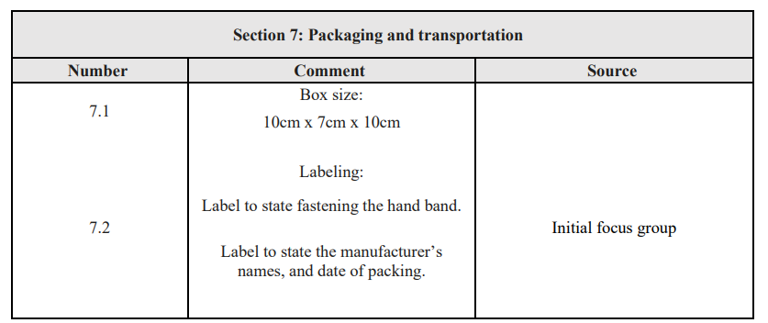
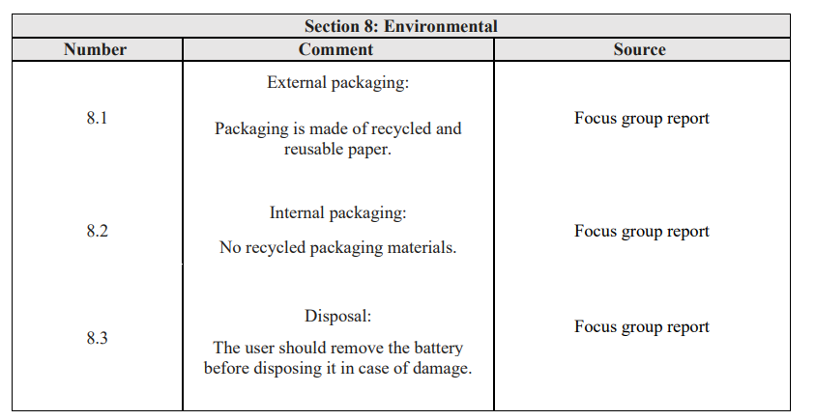
2. Using the Device

2.1Open the website
Web-site name: Wearable IoT Based Device for Critical Care Alzheimer's Patients App.

Sync data:
1) After the countdown, Run the website to sync data;
2) Or next time after you turn on the device, run the website to sync.

NOTE:
The device can store maximum 4 records. The oldest record will be overwritten when the 5th record is coming in.

2.5Real-time Dashboard
You can check real-time measurements.
1) Connect device to Website.
2) Website->Dashboard.

2.6View Results and Report
On in-the website, you can review all the history data. Touch a record, there comes out the detailed report, which includes analysis results.

3. Maintenance

3.1Cleaning
Use a soft cloth moistened with water or alcohol to clean the device’s surface.

3.2Battery
To keep the battery in good condition, charge the battery every 6 months when the device is not in use.
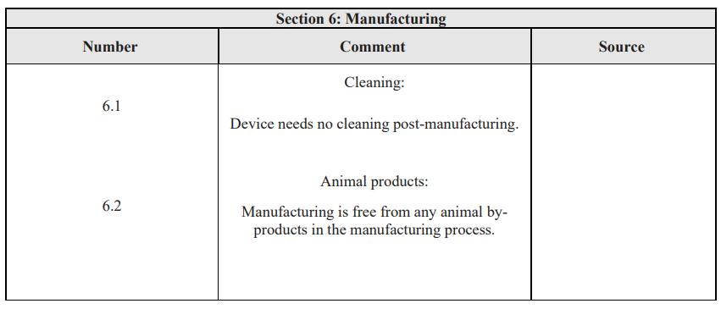

4. Troubleshooting
If your device unit does not seem to be operating correctly, refer to the chart below to determine what may be wrong. Should none of these measures correct the problem, the unit will need servicing.

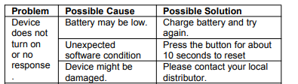

5. Technical Specifications

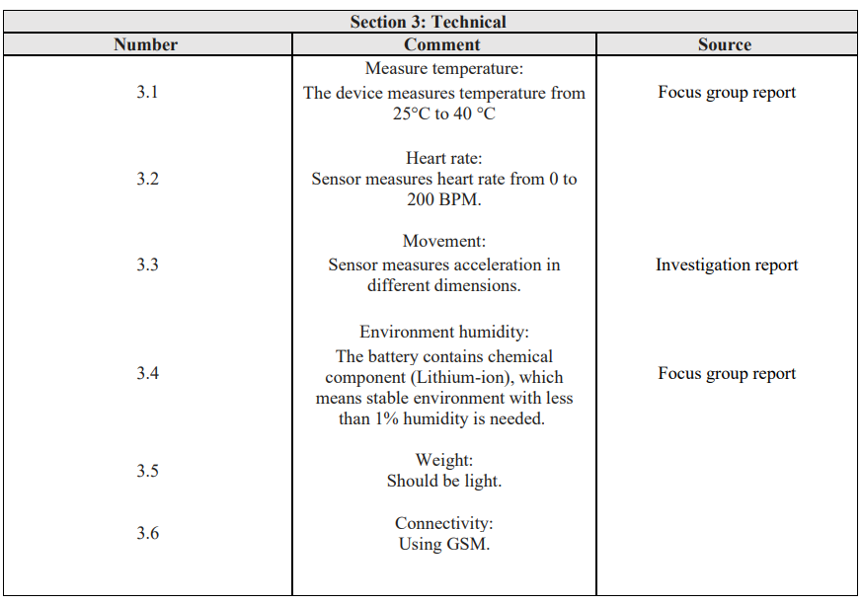

6. Electromagnetic Compatibility
The device meets the requirements of the FDA and CE.

- Warnings and Cautionary Advice

- Using accessories other than those specified in this manual may result in destroying the equipment.
- The device or its components should not be used adjacent to or stacked with other equipment.
- Other devices may interfere with this device even though they meet the requirements of CISPR.
- When the inputted signal is below the minimum amplitude provided in technical specifications, erroneous measurements could result.
- Portable and mobile communication equipment may affect the performance of this device.
- Other devices that have RF transmitter or source may affect this device (e.g., cell phones, PDAs, and PCs with wireless function).

For more information visit our website:
https://zhilife.ac.ae.com

